**AI FOR EVRYONE NOTES**

**Week1**

**Video-1) Introduction**

-Learnt two types of AI

1). ANI – Artificial Narrow intelligence eg. Speech recognition, smart ai speakers, alexa etc….

2) AGI – Artificial General Intelligence = The AI which can do all the work that Human can do.

**Video-2) Machine Learning**

* Learnt Supervised Learning Model which works on Input 🡪 Output
* A🡪B here A is Input and B is Output
* Graph of certain AI sub Domains , at one point of time the graph does not accelerate exponentially but goes in parallel with increase in amount of DATA.

**Video-3) What is DATA?**

* There are two types of Data:

1) Structured Data – MS excel sheet, Data Sheet

2) Unstructured Data – Images, audio, text

Saw an example where data is whether structured or un-structured.

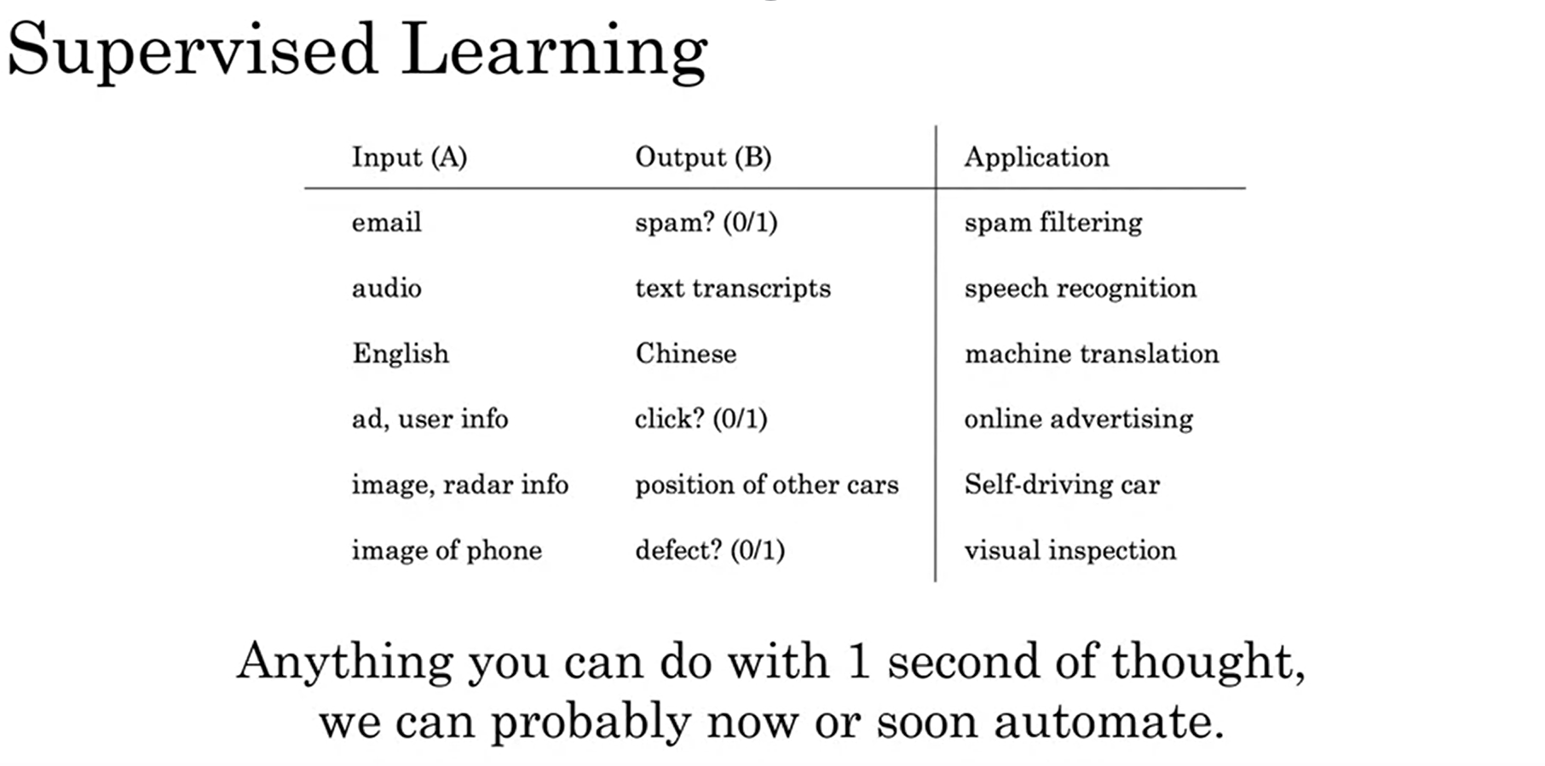

**Video-4) The terminologies of AI?**

Terminologies like Data Science, Machine Learning and Deep learning as well as Neural Networks.

Neural Networks works with connecting neurons to each other and it is the intermediate process for input A and output B.

**Video-5) What makes an AI company?**

Not required first earn then build company

**Video-6) What ML can and cannot do?**

Examples of What AI can or cannot do?  
Its obvious from observation till now that you need a large amount of data, simply 4k-5k data values cannot make your AI system perform well however here we are assuming from the perspective of a company to answer email address/ query addressable system. And to make your AI stable not just you require input A, you also need out B to make ML understand that if this is the case where input is A then formal output will be B.

**Video-7) More Examples of What ML can and cannot do?**

Few examples of self-driving car using ML to drive and medical doctor identifying Pneumonia from few X-ray images whereas AI needs tons of images with labelled to identify whether pneumonia can be identified or not. So this is the example of what AI cannot do. Similarly self-driving can cannot identify the gesture of a person showing hand to show the intension to turn left.

**Week2**

**Video-1) Introduction**

How to decide and work on Building AI projects.

What are the steps to decide AI projects

**Video-2) Working flow of Machine Learning projects**

Three main basic requirements for building ML project are:

1.Collect Data

2.Train Data

3.Deploy Model

Eg. Labelling car images to train and deploy model to detect cars using ML.

**Video-3) Work flow of Data Science Projects**

Three main observations to be observed:

1. Collect Data
2. Analyse Data
3. Suggest Hypothesis/actions

Eg. A mud clay Glass getting manufactured and analysing the process with collecting data like no. of hourse required to keep the product in furnace, which clay heat time was less than other, how much etc…. all types of statistical data.

**Video-4) Every Job Function need to learn How to use data**

Different sectors were shown with their practical application distinguished between Data Science and Machine Learning such as Resume/Hiring process, Marketing sales and agriculture etc… One thing to note is Data Science is the extraction or conclusion/hypothesis made from what is obtained and Machine learning is the result of what previously has been feed.

**Video-5) How to choose an AI project (Part-1)**

The basic idea to choose an AI project is by finding an intermediate area of field between what AI can do and valuable for your business (here business for us means: building an AI project for gaining experience in college)

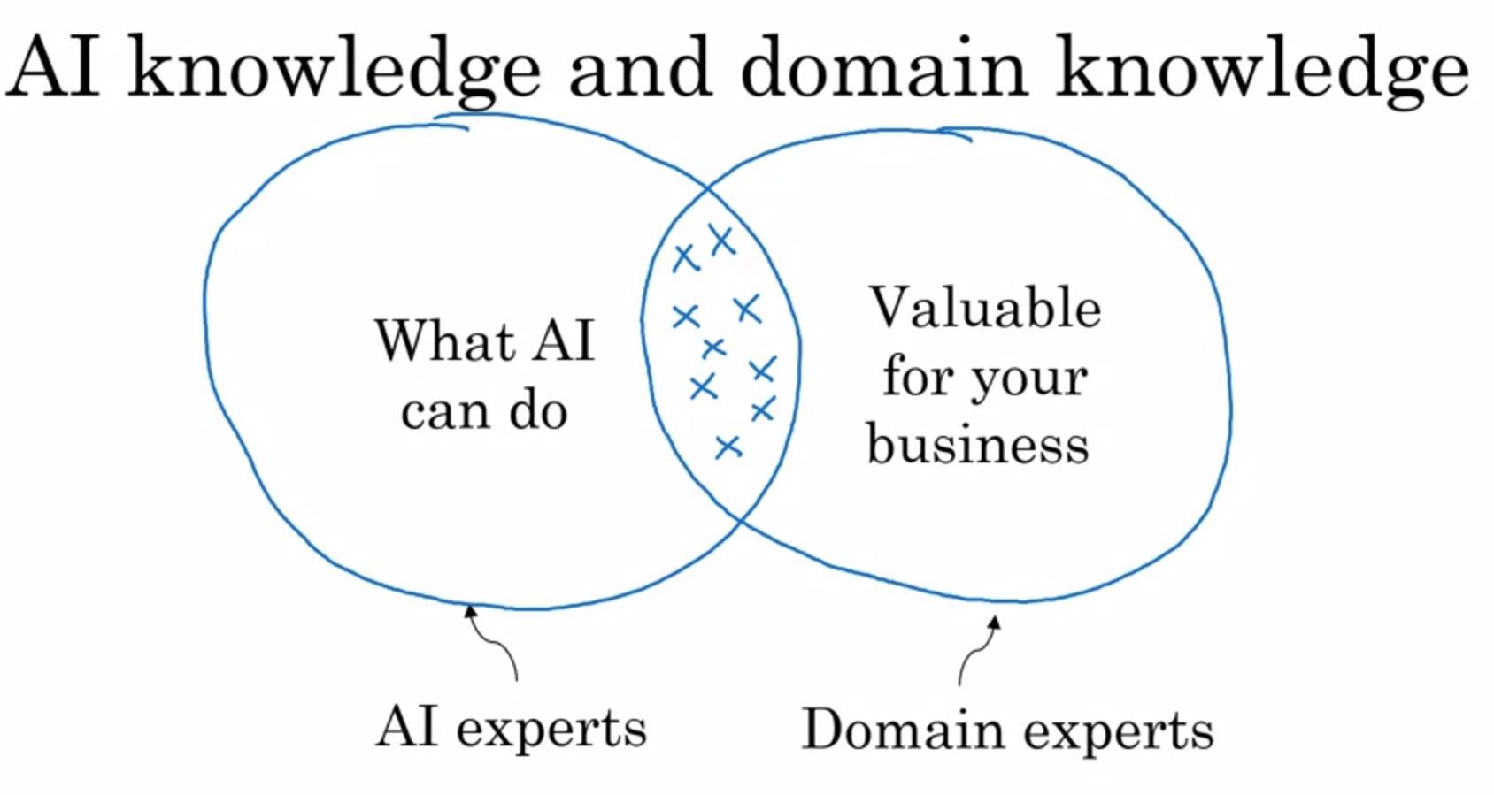

Conclusion: Even with small amount of Data-set still we can progress in our project.

**Video-6) How to choose an AI project (Part-2)**

Here it is discussed to How to doublecheck whether the AI project is worth or not and How many months to close/submit? Etc… decisions

To take those decisions we need to perform two things:

|  |  |
| --- | --- |
| Technical Diligence | Business Diligence |
| Can AI system meet the desired performance | **Lower costs** |
| How much Data is needed | **Increase revenue** |
| Engineering Timeline | **Launch new products or business** |

**Video-7) Working with an AI Team**

AI team should be provided with data set so they can measure the performance in terms of accuracy, faults, miss etc..  
There are two types of data set:

1). Training set

2). Test set

Limitations of ML:

1).Insufficient DATA

2).Mislabelled Data

3).Ambiguous Data

AI Technical Tools:

* TensorFlow
* PyTorch
* Keras
* MXNet
* CNTK
* Caffe
* PaddlePaddle
* Scikit-learn
* R
* Weka

**Week3**

**Video-1) Introduction**

Building AI in you company and its key points discussed.

**Video-2) Case study: Smart Speaker**

When a user is trying to use a smart speaker and suppose says “Hey, device tell me a joke!”  
Then the voice is interpreted into following segments:

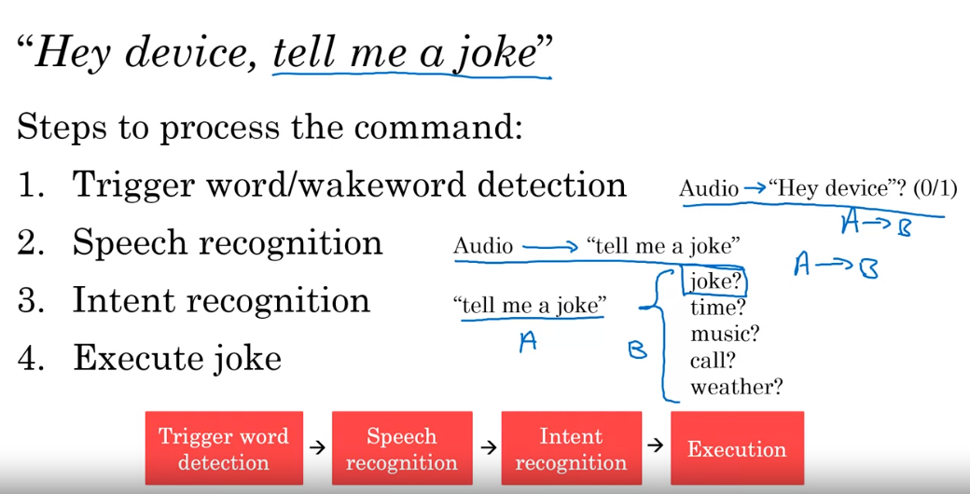

Similarly Frequent other commands can be interpreted like this fashion.

Similarly these is another sample case to study for self-driving cars.

**Video-3) Case study: Self-driving Car**

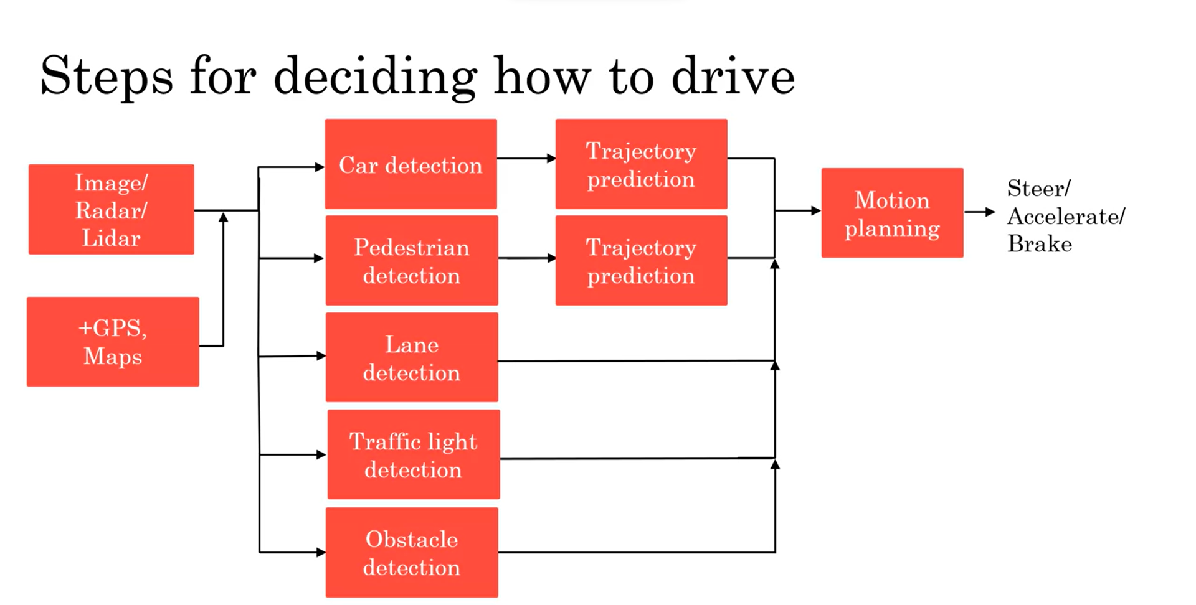

**Video-4) Example roles of an AI Team**

Understand various roles and their working area in their domain.

Various Roles like Software Engineer, Data Scientist, Data Engineer, ML Researcher, ML Engineer, AI project Manager.4

Note: Andrew ng course instructor advice is even if nobody is with you in team and you are alone, imply what you know and start building AI project. Don’t wait. God has planned something for you.

**Video-5) AI transformation Playbook [part-1]**

The course instructor is explain about certain steps:

1). Execute pilot projects to gain momentum

- Project should be more successful rather than valuable

2). Build an AI team

- build a centralize AI team and matrix wise distribute the work under corporate positions like CTO (Chief technical officer,

CIO (Chief Investigation Officer),

CDO (Chief Data Officer) or

CAIO (Chief AI Officer).

3). Provide broad AI training

Few AT Team roles and What they should learn

**Video-6) AI transformation Playbook [part-2]**

4). Develop an AI strategy

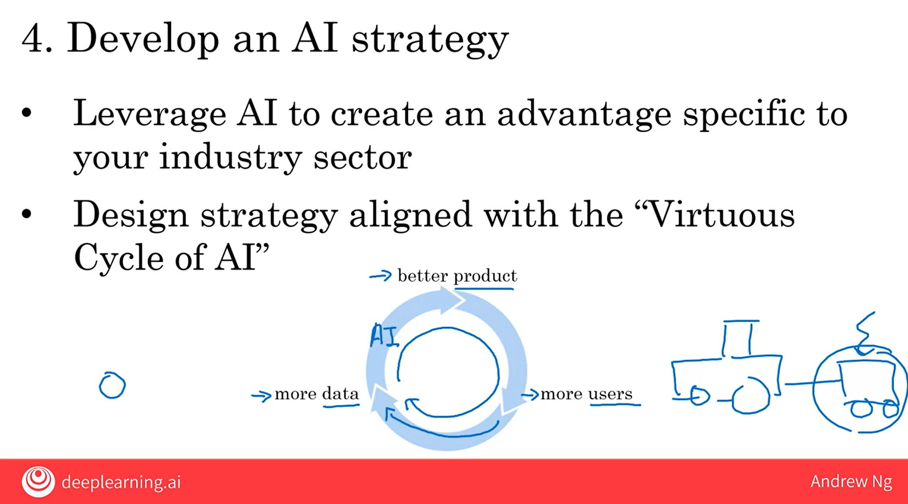

5). Develop internal and external communications

**Video-7) Pitfalls in AI**

Try to avoid the given pitfalls

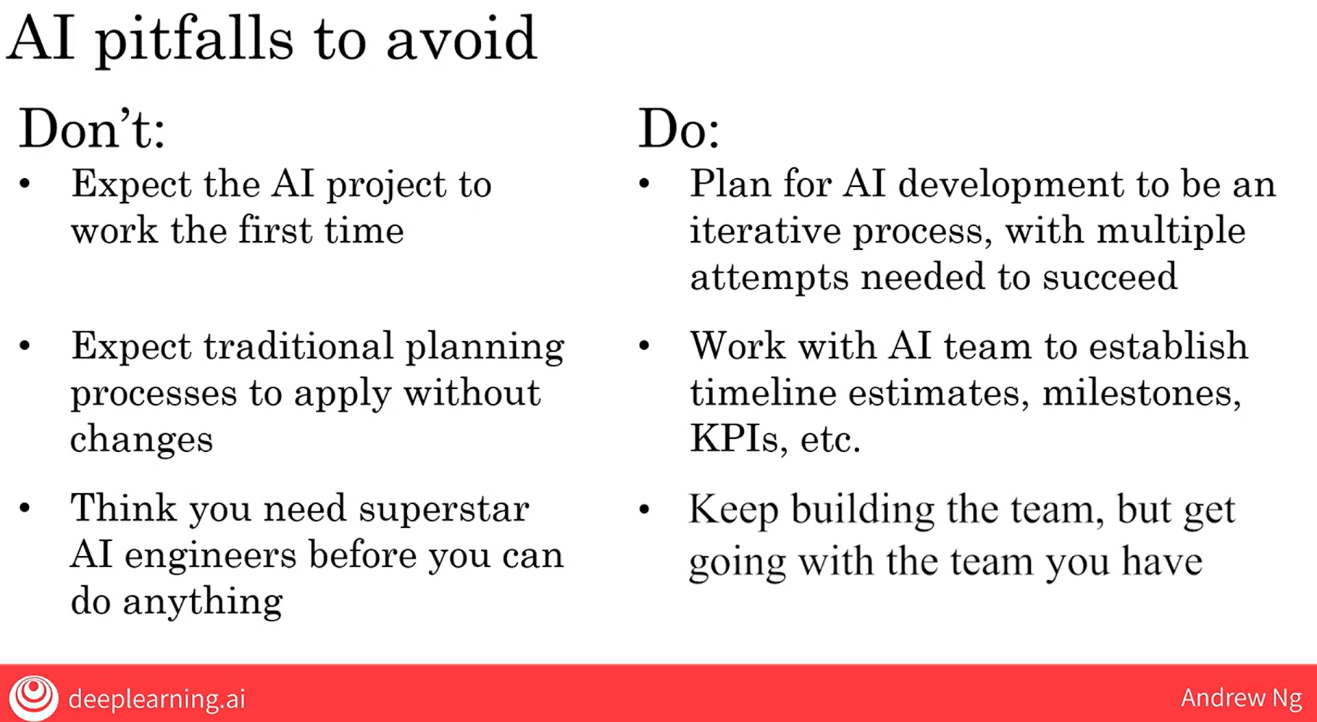

**Video-8) Taking your first step in AI**

Basic understanding of How to initiate project even with small AI team or none.

**Video-9) Survey of major AI application areas**

Understood the concept of Natural Language Processing (NLP) its application in speech and recognition difference between object detection and Image Segmentation AND we found that in Object detection for each object boxes are labelled whereas in Image Segmentation the object is decoded to highlight the full area of object with colour segmenting areas.

**Video-10) Survey of major AI techniques**

Today the value created by Unsupervised learning is much smaller than supervised learning but scientist believe that unsupervised learning will serve as better option in comparison to supervised learning due to the fact that supervised learning needs lots of more data to learn by itself.

**Week4**

**Video-1) Introduction**

Discussed AI ethics and showing the people the difference between AI REALISTIC V/S AI HYPE.

**Video-2) A realistic view of AI**

Understanding the explanation of What AI can do or what AI cannot do and be a realistic review where the course narrator says: Goldilocks rule of AI

1). Too optimistic:

2). Too pessimistic:

3). Just right: “AI can’t do everything, but will transform industries”.

**Video-3) Discrimination/ Bias**

Showed an example where the AI system is shown as biased between Men and Women. So the AI community is trying to combat and diminish the differences between people and their ethnicity.

**Video-3) Adversarial attacks on AI**

This video explains about How AI can be fooled as shown in one of the example we saw that by simply changing few pixel quality of image the AI tool is unable to recognise the same image shown previously but with less quality pixel. In reality it should show the same name by recognition but it does not. Also saw various other types of attacks to make AI fool and fails its recognition pattern. Also establishing AI defences is possible but it incurs much high cost.

**Video-4) Adverse uses of AI**

So considering a test case the narrator wanted to share that with the help of technology like deep fake, it is easy for fraudsters to change something which was never spoken, and similarly its effects on the other dependent things.

**Video-5) AI and developing economies**

The advice give by the narrator to basically focus on the current trends and emerging technologies in AI. Invest into proper channelized market channel.

**Video-6) AI and jobs**

The jobs displayed or prediction which predicted will be less in 2030 but actually the jobs placed will be higher as AI technology increases. The jobs should increase that’s what the narrator tries to tell.

**Video-7) Conclusion**

Thank you Note. Namaste!!!!

Done by **MOHIT GADHVI**VIT UNIVERSITY-VELLORE ---------------------------------------------------